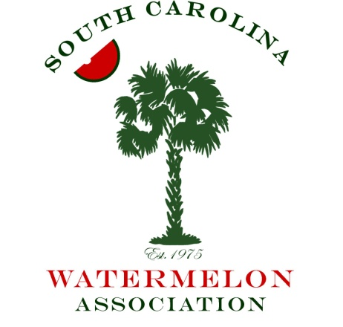
2018 Annual Meeting
Hilton Columbia Center
Columbia, SC

Friday, January 5, 2018

2:00 – 6:00 PM Registration – Lobby of the Hilton

1:30 – 3:30 PM Board of Directors Meeting
SC Watermelon Promotion Board and SCWA Board members

4:00 – 6:00 PM President’s Reception
Light hors d’oeuvres, live music and cocktails

Saturday, January 6, 2018

8:30 AM Registration open

10:00 AM Welcome …….…..…….…………………….……….....…..…………….Gilbert Miller
President, SCWA
Introduction of the
SC Watermelon Queen Program ……………………………..........……... Ann Bryant
SCWA Queen Coordinator

Introduction of Queen Contestants ………………..…….………....Blakely Johnson
Speech & Promotions Wear Competition 2016 SC Watermelon Queen

Legislative update……………………………………………………….Cassidy Evans
SC Farm Bureau
National Watermelon Board Report………………………………..Jason Hanselman

12:00 PM – 1:30 PM Lunch
Buffet featuring South Carolina favorites

Seed Spitting Contest ………………………….……… Queen Contestants and Guests
Stage area

Watermelon Queen Contest Interviews ………... Judges and Queen Contestants Only

2:40 – 6:00 PM Annual SCWA Live Auction and Social……………………Gilbert Miller
President, SCWA

7:00 PM Watermelon Banquet
Seated dinner, service begins at 7pm

Introduction of Judges ………………………………..………………...... Ann Bryant

Evening Gown Competition …………………...………..….…..….. Queen Contestants

Auction Report ………………..…………………………….. Gilbert Miller, President

Crowning of the 2017
South Carolina Watermelon Queen……………………Commissioner Hugh Weathers

Closing Remarks by President …..…………………………................ Gilbert Miller

9:00 PM– Until Melon Ball
Cocktails & Dancing with DJ Gary Brantley

