2019 Midlands Fall Plant & Flower Festival
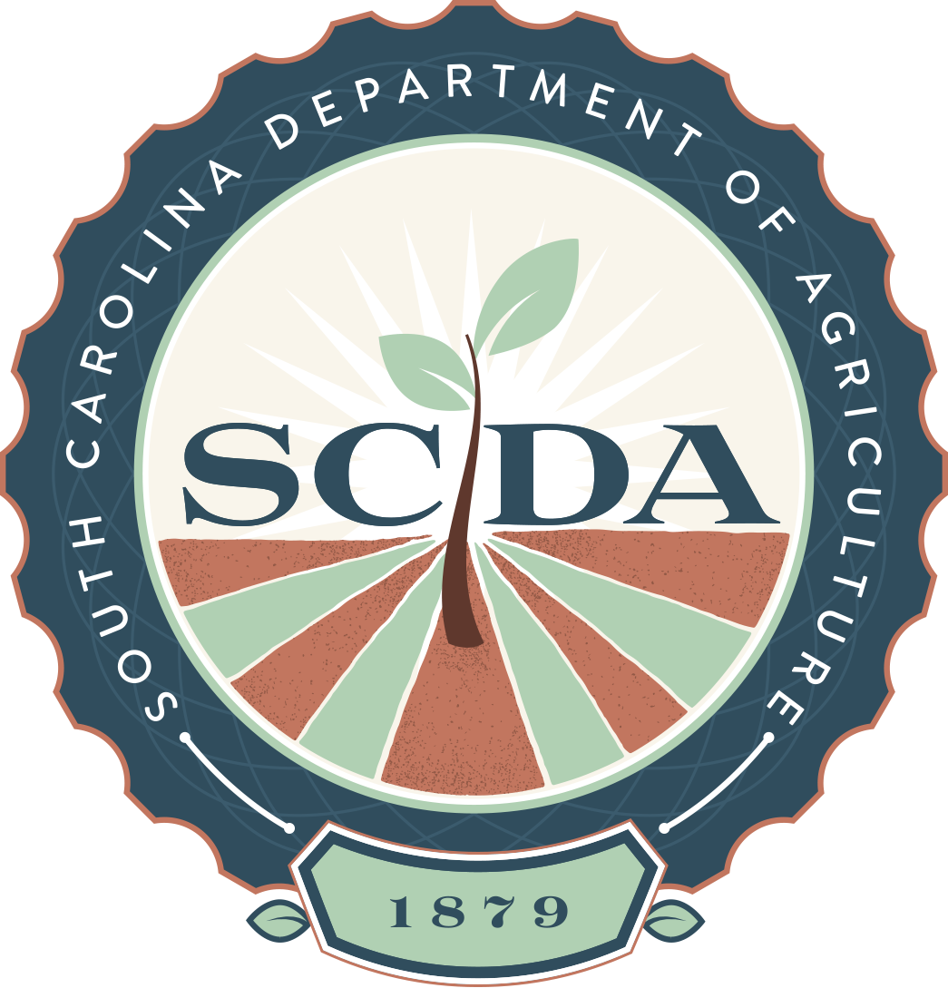

Vendor Application

South Carolina State Farmers Market

3483 Charleston Highway, West Columbia, SC
September 20, 2019—September 22, 2019
Friday & Saturday: 8 a.m. - 6 p.m.

Sunday: 10 a.m. - 4 p.m.

(803) 737-4664

bboozer@scda.sc.gov

sbrazell@scda.sc.gov

Booth fees for the three-day event are $225.00 per space (NON-REFUNDABLE). Payment must accompany a completed application. Please make checks payable to the SC Department of Agriculture and mail to the attention of SC State Farmers Market, 208-A Wholesale Lane, West Columbia, SC 29172. A $50.00 late fee will be applied to applications postmarked after the September 1, 2019 deadline. Applications and checks will be returned once all available spaces are filled. First time vendors must include a picture of booth set-up to be considered. Spaces are approximately 12’x 24’ each. Space assignments will be given at set-up on Thursday, September 19, from 9 a.m. - 5 p.m. All vendors must be off of the premises by 8 p.m. on the day of set-up. Takedown is permitted after 4 p.m. on Sunday, September 22, and not before. Vendor responsibilities include but are not limited to: business licenses, insurance, taxes, and personal requirements including; hoses, chairs, duct tape, electrical cords, tables, signs, etc. Pets are not allowed. Overnight RV’s or campers cannot be accommodated on market property. SCDA is not responsible for lost or damaged products.

Business Name _____________________________________________________________________________________

Address __________________________________________________________________________________________

City __________________________________ State _____________ ZIP _____________________________________

Contact Person _____________________________________ Phone__________________________________________

Email Address _____________________________________ Website_________________________________________

Requested Number of Spaces __________ Special Needs ___________________________________________________

Do you require water? (Yes/No) _____________ Electricity? (Yes/No) (Cannot exceed 220v 20 amps)___________

Describe your product line: (be specific, sales are limited to what is listed) _________________________________

__________________________________________________________________________________________________

Department of Plant Industry Registration number: ___________________________________ State _______________ (required for everyone selling plants)

SCDA issued Registration Verification Certificate number: __________________________________________________
(required for everyone selling packaged food)
Are you a member of Certified South Carolina: (circle one) Yes / No

I have received and read ‘Rules and Regulations for Festivals’ and will abide by them.

_________________________________________________ ____________________________________
Vendor Signature Date

