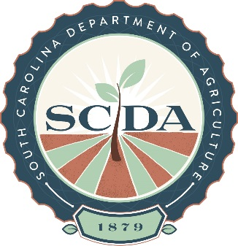

South Carolina Department of Agriculture’s
6th Annual Commissioner’s Cup BBQ Cook-off

Dear BBQ Cook Teams,

The 6th annual Commissioner’s Cup BBQ Cook-off is March 24 & 25, 2017 at the SC State Farmers Market. This event is the SC State Championship BBQ Cook-off and is sanctioned by the Southern BBQ Network. As the SC State Championship, we want to honor the great barbeque we have in this state. This year, the 2017 Commissioners Cup turn in box will require a representation of at least 2 styles of common SC Barbeque to be eligible to win the SC State Championship. We are also excited to add a Kids’ Que to our event this year for children of participating cook teams. Details and the registration form are in this packet. As always, we will be collecting canned goods for Harvest Hope Food Bank. Please read the rules and regulations carefully, as there are new updates and additions. I look forward to seeing everyone in March!

Commissioner’s Cup BBQ Cook-off 2017 will have the following Categories:

“Boston Butts” winning trophies and cash awards of $1900
First place - $1000
Second place - $600
Third place - $300

“Pork Ribs” winning trophies and cash awards of $1900
First place - $1000
Second place - $600
Third place - $300

Cookers competing in butts & ribs are eligible to be awarded as
Grand Champion $600
Reserve Champion $300

“People’s Choice” winning a trophy

Kids’ Que winning trophies and cash awards of $100
Junior Grand Champion $60
Junior Reserve Champion $40

Elizabeth Shuler Wood
Event Coordinator
803-734-2210 | (c) 803-917-4950
ewood@scda.sc.gov

