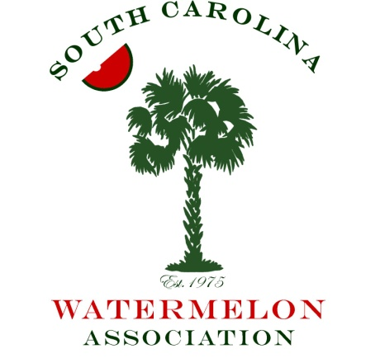

Mark Your Calendar!

The 46th meeting of the South Carolina Watermelon Association will be held on January 5-7, 2018 in Columbia, SC at the Hilton Columbia Center Hotel. We hope you will join us for this exciting event to celebrate the South Carolina watermelon industry and our association.
The Association has planned another fun filled weekend that will offer educational sessions, networking opportunities with retailers, growers and allied industry representatives, and our annual auction to raise funds for research and promotion. We will also crown the 2018 South Carolina Watermelon Queen on Saturday night!
Enclosed are registration forms and the tentative agenda. Registration is $150 per person or $250 per couple if you register before December 15, 2017. After that date, registration will be $200 per person or $350 per couple.
Please make your room reservations directly with the hotel at (803) 744-7800. The rate is $150.00 plus tax per night and includes two breakfast vouchers each morning. Suites are available for $180 per night. Please be sure to tell the hotel you are with the South Carolina Watermelon Association Annual Meeting when reserving your room. The cutoff date for room reservation is December 27, 2017. After that day we cannot guarantee the room rate or room availability. Please make your reservation as soon as possible even if you must cancel at a later date. (Self-parking included/valet parking additional; $24 a day)
We hope that you will accept our invitation to join us in Columbia as we celebrate the South Carolina Watermelon industry on January 5-7, 2018. We look forward to seeing you!

Sincerely,

Gilbert Miller
President, SCWA

