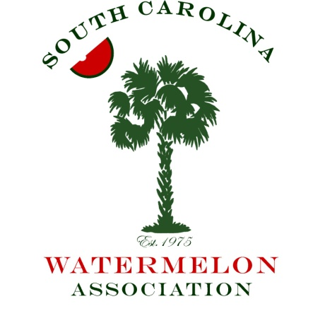

As a valued member of the South Carolina Watermelon industry, you are aware we must continuously improve our operations season after season for long term success. Within this, you play a significant role keeping us technically informed of the best available options. Your innovation, products, and services integrated into our business help us pursue excellence with every planting.

The South Carolina Watermelon Association’s 46th Annual Meeting is scheduled for January 5th through 7th, 2018 in Columbia, South Carolina. Sponsorships significantly improve the overall experience of our meetings. They inform us, energize us, and draw renewed interest in our crops.

This annual event brings together over 150 watermelon producers, shippers, and members of allied industry and provides an upscale environment for constructive dialog and market exposure. Growers are a challenging group to call on with our schedules. Capture this opportunity to connect with us in Columbia and grow your sales.

Enclosed is a description of our Sponsorship options. We invite you to take advantage of this valuable opportunity to place your company in front of the major producers in our state. Our space is limited and we will handle requests on a first come first serve basis. If you prefer to sponsor a particular event on the agenda, we can work with you for a customized plan as well.

Return the sponsorship form to Ms. Ellen Lloyd, Ph. # 803-734-9807, Fax # 803-734-9808, or email elloyd@scda.sc.gov no later than December 1, 2017 to confirm your position. Also note the group rate cutoff date for hotel reservations is December 5, 2017. There are several other events during this same weekend in Columbia so please make your reservations as soon as possible. You can call the Hilton Columbia Center Hotel directly at (803) 744-7800 and tell them you are with the South Carolina Watermelon Association for a rate of $150 plus tax per night.

We look forward to seeing you in our state’s capital!

Sincerely,

Gilbert Miller
President, SCWA

