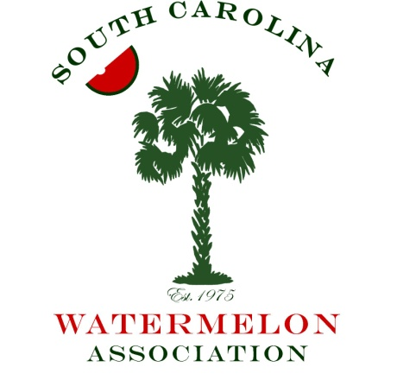
South Carolina Watermelon Association
2018 Annual Convention

January 5 – 7, 2018
Columbia, South Carolina

For more information, contact Matt Cornwell, South Carolina
Department of Agriculture Watermelon Commodity Specialist
Mobile: (803) 206-2409 Office: (803) 734-2225
Email: MCornwell@SCDA.SC.Gov

Jubilee Level Sponsors Donation of $2,000 or Higher
- Your logo/Name on electronic kiosks throughout the Hotel
- Ability to place your promotional items in registration welcome bags
- Your provided materials displayed at the Friday Night Event
- Your graphics on the LCD at the Saturday Lunch Buffet
- Ability to place your marketing information on the tables during lunch on Saturday
- Your name/logo on the official SCWA Convention Koozie
- Full page ad in the convention program at the Jubilee level
- Complimentary Exhibit Space and two Attendee Badges

Allsweet Level Sponsors Donation of $1,500
- Your logo/Name on electronic kiosks throughout the Hotel
- Ability to place your promotional items in registration welcome bags
- Full page ad in the Program at the Allsweet Level
- Complimentary Exhibit Space and two Attendee Badges

Sangria Level Sponsors Donation of $1,000
- Ability to place your promotional items in registration welcome bags
- Half page ad in the convention program at the Sangria Level
- One complimentary Attendee Badge

Crimson Level Sponsors Donation of $500
- Half page ad in the Program at the Crimson Sweet Level

Auction Item Donations
- We greatly appreciate any items you may wish to donate for the live auction. Donors of these items will be recognized during the event.

