South Carolina Department of Agriculture
Hugh E. Weathers, Commissioner
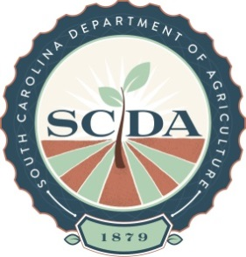

Media Contact: Meredith Atkinson, 803-734-2196, matkinson@scda.sc.gov

FOR IMMEDIATE RELEASE – April 13, 2015

Piedmont Plant & Flower Festival Returns to the Upstate

GREEENVILLE, S.C. –The South Carolina Department of Agriculture is hosting its eighteenth annual Piedmont Plant and Flower Festival at the Greenville State Farmers Market April 30 through
May 3. Event hours are Thursday - Saturday, 8 a.m. - 6 p.m. and Sunday, 10 a.m. – 4 p.m.

The spring festival will have all you need to get your yard ready for the spring season, from seasonal plants, produce, lawn and garden décor, to horticultural accessories and other agricultural items. The Greater Greenville Master Gardeners will also be on-site to answer all of your gardening questions.

The event will take place rain or shine. Admission and parking for the event are free of charge. Visitors are encouraged to dress comfortably and bring along a wagon so that any purchases can be easily transported. The Greenville State Farmers Market is located at 1354 Rutherford Road, Greenville, SC. For additional information, contact Ardona Summerall at 864-244-4023.

###

