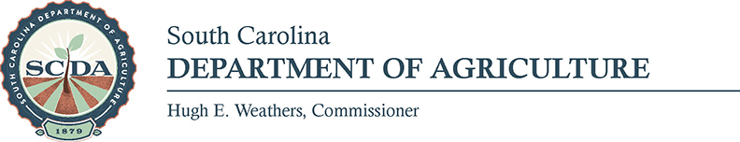

Media Contact: Sally McKay; smckay@scda.sc.gov; 803-734-2196

FOR IMMEDIATE RELEASE – November 6, 2017

USDA Names SC Directors of Farm Service Agency and
Rural Development; Weathers Pleased with Appointments

COLUMBIA – U.S. Secretary of Agriculture Sonny Perdue announced Friday the appointment of Boone Peeler to the Farm Service Agency (FSA) and Debbie Turbeville to Rural Development (RD), both as State Directors. Peeler and Turbeville serve as appointees of President Donald J. Trump.

“Our goal is to help rural America prosper, and these state leaders will be of great assistance in that task,” Secretary Perdue said.

“Boone Peeler and Debbie Turbeville will be excellent representatives of the United States Department of Agriculture (USDA) in South Carolina,” SC Agriculture Commissioner Hugh Weathers said. “They will play an important role in agricultural policy and economic development in our state, and I’m delighted with their appointments.”

Peeler is the Vice President of Harvey Peeler’s Farm, Inc. in Gaffney, SC and a member of the Gaffney city council since 2006. He has worked at the South Carolina Department of Health and Human Services.

“Agribusiness is South Carolina’s largest industry, and I will work tirelessly for our farmers as the state’s FSA state director,” Boone said. “I look forward to working with the USDA and Secretary Perdue and thank President Trump, our state Congressional delegation, and Commissioner Weathers for trusting me with this important position.”

Turbeville of Lake City is a career-long employee of the USDA Rural Development and has served in almost every role at the state level of the agency. Most recently, she was the Area Director for Orangeburg/Aiken and surrounding counties.

“I am thrilled to put my 35 years of experience in Rural Development to work as State Director,” Turbeville said. “Strengthening the economy in rural South Carolina is my passion, and I appreciate the support of Commissioner Weathers for the opportunity to represent the USDA in this capacity.”

FSA State Directors help implement USDA policies in planning, organizing, and administering FSA programs in their respective states. They are also responsible for running the day-to-day activities of the state FSA office. RD State Directors work to help improve the economy and quality of life in rural America.

###

