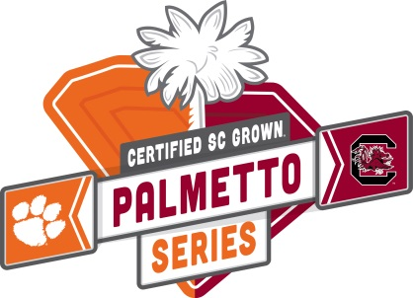
FOR IMMEDIATE RELEASE

Clemson and USC Kick-off Palmetto Series Food Drive to Benefit Harvest Hope and Golden Harvest
Clemson, South Carolina (October 23, 2017) – Today, the University of South Carolina and Clemson University kicked-off the Certified SC Grown Palmetto Series Food Drive in a coordinated effort to benefit Harvest Hope Food Bank and Golden Harvest Food Bank and tackle hunger within their communities. The winner of this match-up will be announced at the Clemson vs. Carolina football game on November 25.
“It’s always great to see two rivals come together for a common cause in the Palmetto Series. Having a canned food drive as part of the series is a great way to help everyone recognize and meet the needs of the hungry in our state,” said Harvest Hope Food Bank CEO Denise Holland. “Seeing the schools’ appetite for victory turned into a drive to end hunger is a win for everyone involved. I’m excited to see what the students, fans, and teams will do to help their neighbors who struggle with hunger on a daily basis.”
The University that raises the most donations in non-perishable foods by November 20 will earn a point for their school towards the 2017-18 Certified SC Grown Palmetto Series standings. Collected food donations between the two schools will be measured in pounds, and money donated will be converted to a number of pounds via an equation used by Harvest Hope and Golden Harvest.
"I am inspired by competitive and passionate students, faculty and community members from Clemson and USC who together are determined to win the most important game: feeding the hungry,” said Golden Harvest Food Bank Executive Director Travis McNeal. “We can always unite to reach out a hand to those in need."
In South Carolina, one in six South Carolina families struggles to find where the next meal will come from, and one in five children will go to bed hungry every night. By participating in the Palmetto Series Food Drive, Tiger and Gamecock fans alike will come together to fight the statewide battle of food insecurities and support Harvest Hope and Golden Harvest.
"Being an athlete at any university is so much more than the medal around your neck or the award hung up on your wall. It embodies being a role model, an active member in the community and, most importantly, giving back to the people that give so much to you, said Emily Radziwon of the Clemson Rowing team. “I have always wanted to use the platform I have as a student athlete to help change the status quo and the Palmetto Series Food Drive has helped me do just that. Let's win as a community and help fight food insecurity together."

To participate in the food drive, the Upstate community is invited to donate canned goods at the following participating BI-LO stores:
- BI-LO 5270 (2901 S Main St, Anderson, SC)
- BI-LO 5277 (1704 E Greenville St, Anderson, SC)
- BI-LO 5566 (7709 Hwy. 76 Pendleton, SC)
- BI-LO 5539 (501 Old Greenville Hwy, Clemson, SC)
Also, donations can be made at any of the on-campus collection points including:
- Cooper Library
- Nieri Student Enrichment Center
- Hendrix Student Center
- Brackett Hall
- Redfern Health Center
- McFadden Athletic Department
- Daniel Hall
- Fike Recreation
- Lightsey Bridge Commons Area
- Core Campus
Clemson fans can also text HHFB Tigers to 501501 to donate $10. For additional program details and/or to donate online, please visit https://goldenharvest.org/blog/event/palmetto-series-food-and-funds-drive.
“Growing fresh food has always been the focus for many of South Carolina’s farmers,” said Commissioner Hugh Weathers. “Farmers consider it a privilege to be part of the fight on hunger and making sure that families across the state have an option to put healthy, local food on their tables.”
To learn more about the Palmetto Series, visit www.palmettoseries.com. You can also connect online with the Palmetto Series on Facebook (/PalmettoSeries), Twitter (@PalmettoSeries) and Instagram (@PalmettoSeries).
###

