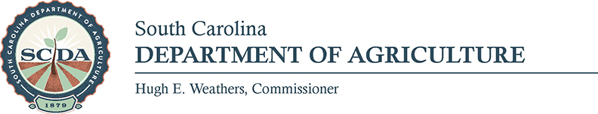

Media Contact:
Elizabeth Wood; 803-917-4950; ewood@scda.sc.gov

FOR IMMEDIATE RELEASE- November 17, 2017

Country Christmas Celebration Returns to State Farmers Market

COULMBIA- The State Farmers Market will take you back in time at the Country Christmas Celebration on Sunday, November 26 from 1 pm – 5 pm. The south certified shed will be transformed into a winter wonderland where you can shop a variety of Christmas trees to the find the perfect one for your home.

While at the event, get a close up look at an assortment of antique tractors and catch the tractor parade at 4 pm. Children can also make and take home Christmas crafts while you listen to festive music and enjoy holiday treats from food vendors. Special guest Santa Claus will be on site passing out candy canes and listening to Christmas wishes. Make sure you bring your camera to take pictures!

This family event is free and a great way to kick off the holiday season. While you are at the market, you can also shop for seasonal produce. The State Farmers Market is located at 3483 Charleston Hwy., West Columbia. For more information, contact Elizabeth Wood at 803-917-4950 or ewood@scda.sc.gov.

###

