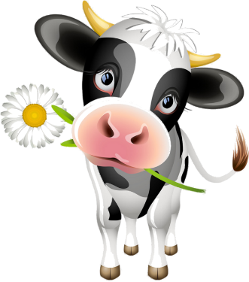
Blue Bird Brand

  - MOO-MOO CONCENTRATE
for Lactating Dairy Cattle

Guaranteed Analysis
Crude Protein (Min)………………….…………………………….26% (This includes not more than 3.5% equivalent crude protein from non-protein nitrogen)
Crude Fat (Min)………………………………………………………..2.5%
Crude Fiber (Max)……………………………………..……………..8.0% Acid Detergent Fiber (ADF) (Max)………………………………14%
Calcium (Min)……………………………………………………………1.0%
Calcium (Max)…………………………….…………………………….1.5%
Phosphorus (Min)……………..…………………………………….0.75%
Selenium (Min)…………………………………….………………0.2 ppm
Vitamin A (Min)………………………………………………6,000 IU/LB

Ingredient Statement

Plant Protein Products, Animal Protein Products, Grain Products, Processed Grain By-Products, Molasses Products, Forage Products, Dicalcium Phosphate, Vitamin A supplement, Urea, Vitamin D3 Supplement, Mineral Oil, Vitamin E Supplement, Hemicellulose Extract, Methionine Supplement, Salt, Ethoxyquin (a preservative), Calcium Carbonate, Manganous Oxide, Magnesium Oxide, Ferrous Sulfate, Calcium Sulfate, Copper Sulfate, Ethylenediamine Dihydroiodide, Potassium Chloride, Sodium Selenite, Potassium Sulfate, Zinc Oxide, Natural and Artificial Flavors.
Feeding Directions:
Feed 16 pounds per head per day to a 1,200 pound cow. Feed 18.6 pounds per head per day to a 1,400 pound cow. Do not exceed 50% of the total dry matter intake from this feed.

Manufacturer Name
123 Main Street
Anytown, SC 29999

Net WT 50 LB (22.67 kg)

