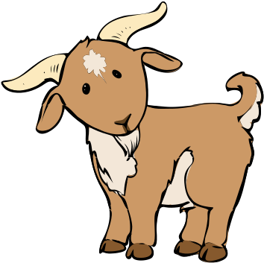
Blue Bird Brand

  - PRIME 15% GOAT FEED
For finisher goats.
Guaranteed Analysis
Crude Protein (Min)………….………….……………………….15.0% (This includes not more than 1.0% equivalent crude protein from non-protein nitrogen)
Crude Fat (Min)……………….………………………………………..5.0%
Crude Fiber (Max)……………….…………………..……………..18.0% Acid Detergent Fiber (ADF) (Max)……………………………22.7%
Calcium (Min)……………………………………………………………1.0%
Calcium (Max)…………………………….…………………………….1.5%
Phosphorus (Min)……………..…………………………………….0.45%
Salt (Min)…………………….………………………………………….0.25%
Salt (Max)……………………….……………………………………….0.65%
Copper (Min)………………………..……………………………….5.0 ppm
Copper (Max)………………………………………………………10.0 ppm
Selenium (Min)…………………………………….………………0.5 ppm
Vitamin A (Min)………………………………………………5,000 IU/LB

Ingredient Statement
Grain Products, Plant Protein Products, Processed Grain By-Products, Roughage Products, Ammonium Chloride, Vitamin A supplement, D-Activated Animal Sterol (source of Vitamin D), Choline Chloride, Biotin, Thiamine Mononitrate, Pyridoxine Hydrochloride, Vitamin E Supplement, Copper Sulfate, Folic Acid, Ethoxyquin (a preservative), Calcium Carbonate, Dicalcium Phosphate, Monocalcium Phosphate, Manganous Oxide, Zinc Oxide, Ferrous Sulfate, Cobalt Carbonate, Potassium Chloride, Sodium Selenite.
Feeding Directions:
Feed as the sole source of grain to finisher goats at the rate of 2 to 3 pounds per head per day.
Manufacturer Name
123 Main Street
Anytown, SC 29999

Net WT 50 LB (22.67 kg)

