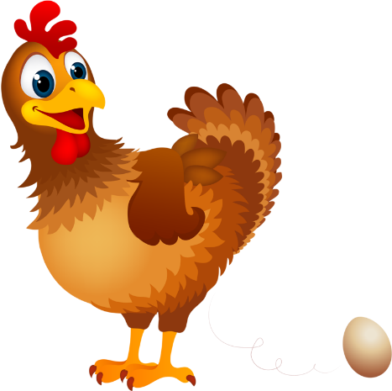
Blue Bird Brand

  - HAPPY HEN LAYER FEED
Complete Feed for Laying Chickens

Guaranteed Analysis
Crude Protein (Min)…….………...………………….……..……….17.0%
Lysine (Min)……………….…………..…..…………………………….0.60%
Methionine (Min)………………………….…………………………..0.30%
Crude Fat (Min)…………………..…..………………..……….………..5.0%
Crude Fiber (Max)……………..…..……………………..……...……..2.0%
Calcium (Min)………………………….………………………………..…4.0%
Calcium (Max)………………………….….………………………..…….5.0%
Phosphorus (Min)……………….……………………………..……….0.8%
Salt (Min)…………………………………………………………..……..0.5%
Salt (Max)…………………………………………………………..….……0.75%

Ingredient Statement

Processed Grain By-Products, Plant Protein Products, Grain Products, Vitamin A supplement, Animal Protein Products, Vitamin D3 Supplement, Vitamin E Supplement, Niacin Supplement, Calcium Pantothenate, Riboflavin Supplement, Choline Chloride, Folic Acid, Methionine Supplement, Potassium Sulfate, Calcium Carbonate, Menadione Sodium Bisulfate Complex (Source of Vitamin K Activity), Salt, Manganous Oxide, Zinc Oxide, Copper Sulfate, Ethylenediamine Dihydroiodide, Ferrous Sulfate, ,Sodium Selenite.
Feeding Directions:
This is a complete and balanced ration. Feed Happy Hen Layer Feed from time first egg is laid throughout the time of egg production.

Manufacturer Name
123 Main Street
Anytown, SC 29999

Net WT 50 LB (22.67 kg)

