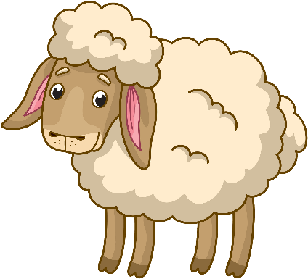
Blue Bird Brand

  - BEST SHEEP FEED
For breeding ewes.
Guaranteed Analysis
Crude Protein (Min)……………………….……………………….18.0% (This includes not more than 1.2% equivalent crude protein from non-protein nitrogen)
Crude Fat (Min)…………………………………………………………..5.0%
Crude Fiber (Max)……………………………………..……………..22.0%
Calcium (Min)……………………….……………………………………1.0%
Calcium (Max)……………………….…….…………………………….1.5%
Phosphorus (Min)……………..…………………………………….0.45%
Salt (Min)…………………….………………………………………….0.25%
Salt (Max)……………………….……………………………………….0.65%
Copper (Min)………………………….…………………………….5.0 ppm
Copper (Max)……………………………..………………………10.0 ppm
Selenium (Min)…………………………………….………………0.5 ppm
Vitamin A (Min)………………………………………………5,000 IU/LB

Ingredient Statement
Grain Products, Processed Grain By-Products, Roughage Products, Plant Protein Products, D-Activated Animal Sterol (source of Vitamin D), Ammonium Chloride, Vitamin A supplement, Thiamine Mononitrate, Pyridoxine Hydrochloride, Choline Chloride, Biotin, Vitamin E Supplement, Folic Acid, Copper Sulfate, Calcium Carbonate, Dicalcium Phosphate, Ferrous Sulfate, Monocalcium Phosphate, Ethoxyquin (a preservative), Manganous Oxide, Potassium Chloride, Zinc Oxide, Cobalt Carbonate, Sodium Selenite.
Feeding Directions:
Feed as the sole source of grain to breeding ewes at the rate of 2 to 3 pounds per head per day.
Manufacturer Name
123 Main Street
Anytown, SC 29999

Net WT 50 LB (22.67 kg)

