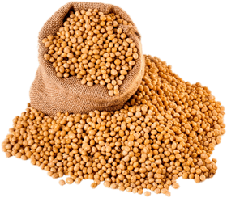
Blue Bird Brand

  - SOYBEAN MILL FEED
Feed Ingredient

Guaranteed Analysis
Crude Protein (Min)………………..……….……………………….18.0%
Crude Fat (Min)………………………..……..…………………………...0.5%
Crude Fiber (Max)………………………………….…………………….30.0%

Distributer Name
123 Main Street
Anytown, SC 29999

Lot #8642
Net WT on Bulk invoice

