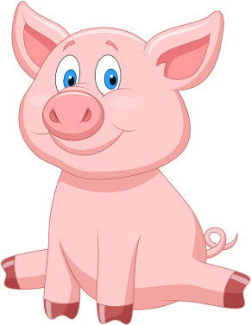

Blue Bird Brand

  - PIG FEED
For Growing Pigs Weighing 44 to 110 lbs.

Guaranteed Analysis
Crude Protein (Min)…………………………………………………….25%
Lysine (Min)……………………………………………………….………1.5%
Crude Fat (Min)………………………..…………………………………..8%
Crude Fiber (Max)………………….…………………..………………..6%
Calcium (Min)……………………………………………………………1.1%
Calcium (Max)…………………………….…………………………….1.6%
Phosphorus (Min)……………..…………..……………………….0.80%
Salt (Min)………………………………………..………………………0.20%
Salt (Max)…………………………………………………………………0.45%
Selenium (Min)……………………………..………….…………0.2 ppm

Ingredient Statement

Plant Protein Products, Grain Products, Processed Grain By-Products, Animal Fat, Dried Whey, Vitamin A supplement, Calcium Lignin Sulfonate, L-Lysine, Riboflavin Supplement, D-Activated Animal Sterol (source of Vitamin D), Choline Chloride, Thiamine Mononitrate, Pyridoxine Hydrochloride, Biotin, Vitamin E Supplement, Folic Acid, Menadione Sodium Bisulfite Complex (source of Vitamin K Activity), Limestone, Dicalcium Phosphate, Salt, Copper Sulfate, Manganous Oxide, Zinc Oxide, Ethoxyquin (a preservative), Iron Sulfate, Calcium Iodate, Cobalt Carbonate, Sodium Selenite.

Feeding Directions:
Feed as the complete ration to growing pigs weighing 44 to 110 pounds.

Manufacturer Name
123 Main Street
Anytown, SC 29999

Net WT 50 LB (22.67 kg)

