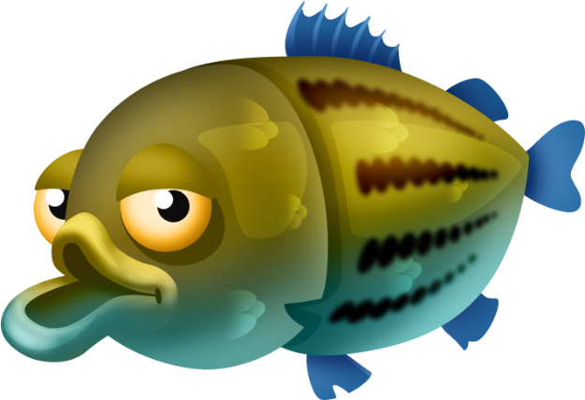
Blue Bird Brand

  - TROUT PELLETED FEED
.

Guaranteed Analysis
Crude Protein (Min)………………..……….……………………….40.0%
Crude Fat (Min)……………………………..…………………………..11.0%
Crude Fiber (Max)………………………………….…………………….6.0%
Phosphorus (Min)……………..….……………..……..………..…….0.8%

Ingredient Statement
Fish Meal, Soybean Meal, Fish Oil, Wheat Flour, Feather Meal, Vitamin A Supplement, L-ascorbyl-2-polyphosphate, Lecithin, Riboflavin Supplement, Choline Chloride, Thiamine Mononitrate, Biotin, Pyridoxine Hydrochloride, Ethoxyquin (a preservative), Folic Acid, Copper Sulfate, Lignin Sulfonate, Magnesium Sulfate, Ferrous Sulfate, Potassium Iodate, Zinc Sulfonate.

Feeding Directions:
Feed as the sole ration to trout.

Manufacturer Name
123 Main Street
Anytown, SC 29999

Net WT 50 LB (22.67 kg)

