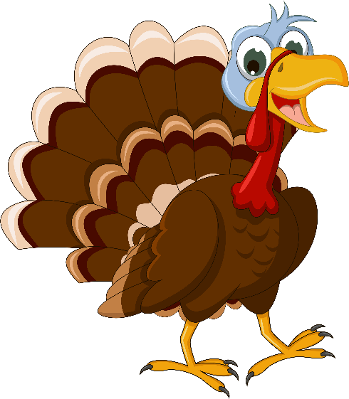
Blue Bird Brand

  - TURKEY COMPLETE FEED
For finishing turkeys.

Guaranteed Analysis
Crude Protein (Min)………………..……….……………………….20.0%
Lysine (Min)……………………..………………………………………..0.75%
Methionine (Min)……………..……………………………………..0.40%
Crude Fat (Min)…………….……………………………………………..5.0%
Crude Fiber (Max)………………………………………………………..5.0%
Calcium (Min)……………………..…………………….…………………2.0%
Calcium (Max)………………………..…….………….………………….2.5%
Phosphorus (Min)……………..…….……………….……………….0.6%
Salt (Min)…………………….………….…….………………………….0.40%
Salt (Max)……………………….…………….………………………….0.50%

Ingredient Statement
Processed Grain By-Products, Plant Protein Products, Grain Products, Animal Fat, Vitamin A supplement, Lignin Sulfonate, D-Activated Animal Sterol (source of Vitamin D), DL-Methionine, Biotin, Riboflavin Supplement, L-Lysine, Choline Chloride, Pyridoxine Hydrochloride, Vitamin E Supplement, Thiamine Mononitrate, Menadione Sodium Bisulfite Complex (source of Vitamin K Activity), Limestone, Folic Acid, Ethoxyquin (a preservative), Dicalcium Phosphate, Calcium Iodate, Salt, Ferrous Sulfate, Manganous Oxide, Zinc Oxide, Cobalt Carbonate, Copper Sulfate, Sodium Selenite.

Feeding Directions:
Feed as the complete ration to turkeys greater than 16 weeks of age being fed for market.
Manufacturer Name
123 Main Street
Anytown, SC 29999

Net WT 50 LB (22.67 kg)

